Long-Term Care Programs Offered in the Community
Introduction
- The health care services and programs available in the communities are essential in promoting good health and quality health among the community members.
- A community that is focused on maintaining healthy lives of the community members has programs that cater to all the members of the society. Both pediatric, adult care, care for the disabled and more significantly the maternal care (Gyasi, Phillips, &Buor, 2020).
- Community health is a medical specialty that focuses on the physical and mental well-being of the people in a given geographical area, and our community is an example of such communities.
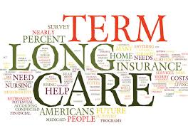
- The significance of community health involves improving the health of all the community members, preventing the spread of infectious diseases and helps the society members to prepare for natural disasters (Gyasi, Phillips, &Buor, 2020).
- The long-term care involves many services that have been designed to meet an individual's health as well as personal care for a short or long period. These services are critical in helping people to live independently and lead healthy lives as much as possible.
- If the community is unhealthy, then it is quite hard for a person to be healthy while in the same community. This is because community member share resources, and thus the dissemination of infections.
- The main focus of this newsletter is enlightening the community members on the healthcare resources available to better their health and thus educated than on the best actions to take for quality health.
Types of programs and services for long-term care populations
- Our community has many programs that have been deemed critical in improving community health, and these programs include:
- Medicaid programs: These programs offer broad levels of health insurance coverage like clinical visits, nursing homes, family care, and hospital expenses. Additionally, the Medicaid services also cover long-term care costs for patients addressed at home as well as in nursing homes (Storms, Marquet, Aertgeerts, &Claes, 2017).
- Medicare health program: This program is funded by insurance for people aged 65 years or older. As well, some categories of people younger than 65 years are incorporated in these essential programs, especially when they have disabilities. More significantly, people with End-Stage Renal Disease and covered under Medicare.
- Home health care: The main focus of this program is to include nursing people to recover from surgeries, accidental injuries, and threatening illnesses. Authorized agencies offer speech therapy, physical care, and non-permanent healthcare services by Medicare (Gyasi, Phillips, &Buor, 2020).
- Senior transportation services: Without adequate transportation, access to emergency care is quite hard, and thus our community has effective community-group transportation service that intervenes. Surprisingly, most of the emergency transportation services in our community are free, and only a few are charged fairly.

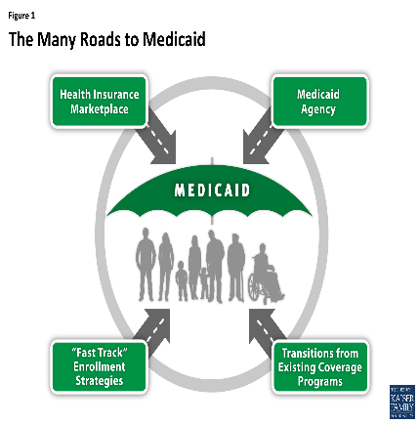
- Emergency medical alert systems: Currently, our community has effective automated electronic systems that help in notifying the relevant agencies on the needed care by community members (Kruse et al., 2017). People who live alone are the primary beneficiaries of these programs and has a monthly subscription fee.
- Long-term care planning: Our community encourage all its members, especially the ageing people, to develop the interest of the long-term care planning programs. These programs include advance care planning as well as programs for caring or Alzheimer's disease patients. The advance directive is essential in helping one to make health care decisions.
- Maternal and child survival programs: Maternal health is much encouraged in the United States of America, and so it is in our communities. This helps in giving birth to healthy and reproductive children. The program has been ranked first in intervening for expectant mothers and preventing maternal deaths.
- Dental health programs: This program in non-clinical managed by specialized dentists who help in preventing oral infections and promoting oral health.
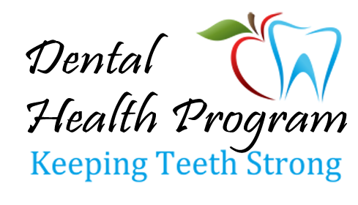
- Nutrition and dietetics programs: Our community leaders have been recognizant that poor and unhealthy eating habits lead to infections (Kruse et al., 2017). Overeating leads to obesity and thus, a series of other diseases. Under nutrition leads to nutrient deficiency and thus exposing the body to infections.
- Mental health and psychiatric care: The mentally ill patient has a specialized program in which they can seek mental healthcare. Some qualified psychiatrists are willing to address all forms of mental health issues.
Communication in the community on health care programs
- The primary method by which the above programs reach out to their potential clients is advertising. These adverts are done on social media platforms like Facebook and Twitter. The audio and audio-visual applications are also used in adverts. Billboards and hiring advertising agencies have been essential in promoting knowledge of health programs.
- The main methods of providing critical information to the community include;
- Forums in which the essential community information is posted on WebPages for the community members to access.
- Use of telephone in making calls, especially conference calls and texts messages.
- Communication through broadcasting.
- E-mail communication from the community leaders.
- At times, face-to-face communication is also organized by community leaders (Middleton, Moxham, & Parrish, 2016).
- Currently, the social media platform is commonly used to pass critical information.
Analysis of the community programs and services for long-term population
- From an analytical point of view, the community has many applications which are critical in promoting good health. However, of all the programs, the Medicare programs and care for the elderly is most vital (Lam et al., 2018).

- Additionally, the maternal healthcare services are highly valued for proving care to the expectant mothers as well as pediatric care to children below five years old.
- The home care essential services are as well being encouraged in the community to prevent the accumulation of the many patients in the healthcare organization and thus increased potential of acquiring hospital-acquired illnesses.
Analysis of the social programs and services in the community
- Our community emphasizes on the significance of quality health, and thus health issues are the most valued (Issel& Wells, 2017).
- In every village, there is at least one healthcare organization that can offer the most basic care to the community members, and this is essential in promoting the social services of health.

- Generally, the community has improved hygiene program, and this has been critical in managing good health.
- Quality communication services are essential in the community, and they have been facilitating good attendance for emergency services.
Educational programs and services for long-term care populations
- In our society, there are learning institutions which promote the attainment of professional levels and thus producing workers in the healthcare sector.
- The education and community-based program are forced on the prevention of disease and injury, improvement of health, and enhancement of quality life.
- Under the basic education programs that are offered children, hygiene management practices like hand washing and practicing effective preventative mechanics are encouraged the acquisition of personal health management competencies (Storms, Marquet, Aertgeerts, &Claes, 2017).
- At the healthcare facilities, there are patient-education programs that have been designed based of evidence-based research to educate the community members on the significance of quality health and the best practices they should get involved in for infection management and prevention.
- Additionally, there are nursing colleges and other institutions that have been ranked highly in promoting quality education healthcare practitioners, and this helps in equipping our society with competent clinicians for health promotion.
- More significantly, there are research institutions in which clinical researches are conducted to help in solving the problems in our healthcare systems and thus emphasizing on evidence-based healthcare practices.
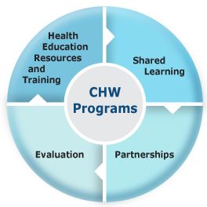
- There are community-based programs that are facilitated by the government, donors and healthcare organization that educating all the community members on the topic such as chronic diseases, mental illnesses, oral health, tobacco use, unintended pregnancy and more so the outbreak of infections like Covid-19 (Storms, Marquet, Aertgeerts, &Claes, 2017).
The benefits of social and educational programs and services
- Prevention of disease and injuries by providing people with quality health management practices.
- Improving health through the provision of evidence-based care.
- Enhancing quality of life and thus making the community members more productive.
- Challenging the community practice that does not promote quality healthcare practices.
- Producing qualified professionals to work as service providers and thus offering improved health care service.
Sources of funding for community, social, and educational programs and services.
- The government facilitates the primary educational programs with the help of parents.
- Community health education programs are funded by the government as well as healthcare organizations.
- The Federal government funds the Medicare program (Middleton, Moxham, & Parrish, 2016).
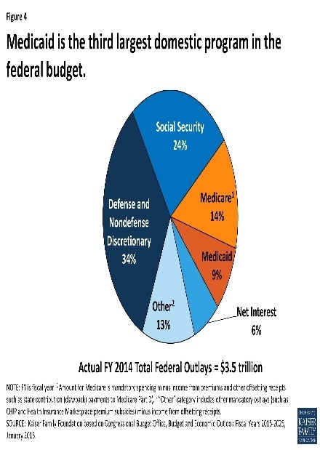
- Individual society members support tertiary education programs with financial aids from the Federal government. Scholarship programs are also available in society.
- Existing organizations facilitate some of the community education programs. For example, obesity care programs are managed by the organizations' owners with the help of donors.
- The World Health Organization (WHO) has been offering financial aids for running applications like medical researches for health promotion.
- Most of the healthcare organizations retrieve their profits to finance critical social programs that are related to health.
The impacts of reimbursement on long-term care and specific community health programs
- The reimbursement of the helps in attainments of equality and promoting ethical perspectives to the community members.
- The most common reimbursement programs include Medicare reimbursement that is offered when the patients are not given the anticipated attention as they seek healthcare services.
- Effective data collection and healthcare programs are emphasized to approve the services provided to community members who claim reimbursement and this helps in promoting fairness in the healthcare institutions.
- The health insurance companies have been leading in pushing for the reimbursement of community members who have complains on poor healthcare services.
- The patients are free to seek compensation for the wrong medication, and this is done with the help of judicial agencies.
Licensure requirements for programs and services
- The healthcare workers are required to operate with a renewable license for them to be authorized in offering medical services. For example, the nurses are required to register under the American Nurse Association (Storms, Marquet, Aertgeerts, &Claes, 2017).

- The licensure requirements involve education, training, and internship practices for healthcare workers to be recognized as qualified professionals.
- All the healthcare organizations in the community must operate with legal authorization from the government. There are necessary facilities available for healthcare organizations to be granted permission to offer healthcare services (Storms, Marquet, Aertgeerts, &Claes, 2017).
- All the learning institution in our community must be accessed continually to confirm if they meet the anticipated level of educational organizations in the U.S. for them to be allowed to operate.
Current trends and issues in long-term care
- The outbreak of infections like Covid-19 has been affecting the operations of long-term care programs.

- Shortage of essential staff has been the long-existing controversy in the long term care facilities, and this has been pulling back the operations of the programs.
- An increased focus on the person-centered care that gives every person an autonomy over his or her health and thus needing the healthcare practitioners to be keen in adhering to the nursing principles (Issel& Wells, 2017).
- The incorporation of technology on long-term care has promoted faster, safe and effective healthcare services.
- Increased number of ageing people and thus putting the Medicare services in high demand and implying that programs like dementia care and end of life infections are on the increase in the community.
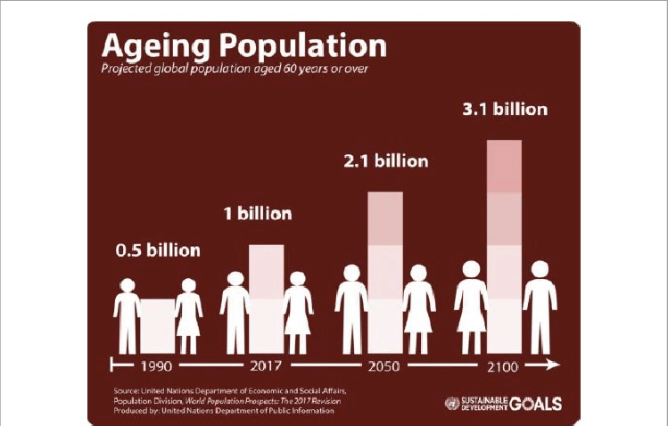
How the programs and services fit within, or miss the mark, with these trends and issues
- The trends have been promoting changes in long-term care programs. New technology has improved ease of work and increased efficiency of healthcare services.
The increased number of ageing is helping the long-term program to focus on the level of care that will be needed shortly and thus initiate mechanisms to fit for the same.
- The emergency of infections like Covid-19 has compromised the level of care offered in the long-term programs due to the increased number of people in need of the necessary services and thus the issue of both human and financial resource shortages have been recorded.
How community programs and services promote health and wellness concepts to address the needs of various LTC populations
- In the community, the needs of LTC populations are prioritized, and thus the health of specialized group in the community is emphasized.
- The nutritional and health promotion programs have prompted longer and healthy lives among the elderly members of the community. Elderly intellectual stimulation, community care for all ages and the general wellness of the community member have been attained with the help of LTC programs (Lam et al., 2018). Sharing of healthcare information among the community members have been comfortable due to the advancements in technology and response programs in the community.
- Most of the older adults, needy members of the community and caregivers now feel comfortable discussing health and social issues since there are programs ready to respond and improve their health care services.

References
Gyasi, R. M., Phillips, D. R., &Buor, D. (2020). The role of a health protection scheme in health services utilization among community-dwelling older persons in Ghana. The Journals of Gerontology: Series B, 75(3), 661-673.
Issel, L. M., & Wells, R. (2017). Health program planning and evaluation: A practical, systematic approach for community health. Jones & Bartlett Learning.
Kruse, C. S., Mileski, M., Vijaykumar, A. G., Viswanathan, S. V., Suskandla, U., & Chidambaram, Y. (2017). Impact of electronic health records on long-term care facilities: systematic review. JMIR medical informatics, 5(3), e35.
Lam, H. R., Chow, S., Taylor, K., Chow, R., Lam, H., Bonin, K., ... & Herrmann, N. (2018). Challenges of conducting research in long-term care facilities: a systematic review. BMC geriatrics, 18(1), 242.
Middleton, R., Moxham, L., & Parrish, D. (2016). The value of health promotion programs for older people with chronic conditions in the community. Australian Nursing and Midwifery Journal, 24(2), 30.
Storms, H., Marquet, K., Aertgeerts, B., &Claes, N. (2017). Prevalence of inappropriate medication use in residential long-term care facilities for the elderly: A systematic review. European Journal of General Practice, 23(1), 69-77.

